People who have marked the history of Romania

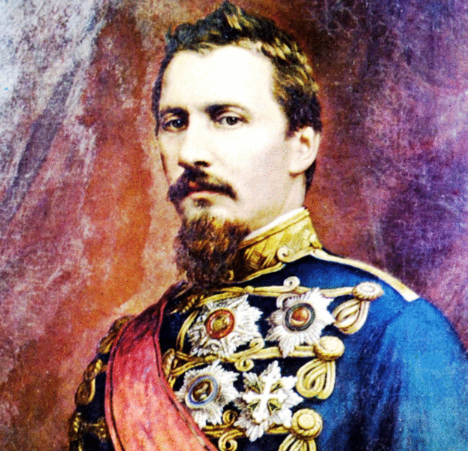
ALEXANDRU IOAN CUZA

The United Principalities represent the first stage of the Grand Union or the Unification of Romania. Therefore, this event is the one that had a huge impact on the history of the Romanians and on the democracy of the country. Alexandru Ioan Cuza is considered to be the one who gave birth to the modern polity. The 24th of January(1859) is the day when the Romanian state entered the modern period, bringing at the same time reforms that Alexandru I. Cuza was to start, even though not all of them were to be finished. His name remains linked to the idea of reform and modernization of the Romanian state.
Cuza’s personality still raises question marks in history because he had an extremely controversial reign, meaning that it began full of hope, but ended in a clash with the political elite of that time. He was accused that he wanted to impose a dynasty of his own and this is the reason why, after a fight with the Parliament, a political conspiracy was prepared against him, that led to his removal and his replacement with King Charles I.
But what did A. I. Cuza exactly do? Most importantly, he was the one who established the unification of Moldavia and Wallachia. In another words, Romania was born. Romania: a modern European state, having Bucharest as the capital of the country and finally having occidental influence.
To sum up, the main idea is that if it wasn’t for Alexandru Ioan Cuza, Romania would not have become a democratic united country as today.
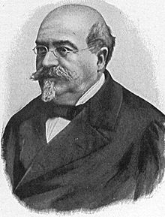

MIHAIL KOGĂLNICEANU

Mihail Kogălniceanu was a lawyer, a poet and most importantly, he was a Romanian politician, a liberal statesman. Even though he did not live during any democratic regime and he had many conflicts with the Prince then, Alexandru Ioan Cuza, Kogalniceanu's acts were some of the first steps towards a regime based on democratic principles. Sliding his career with the moderate liberal current for most of his lifetime, Kogălniceanu started his career by abolishing Roma slavery.
He had a huge influence on the Divan, a national meeting where his friend, Alexandru Ioan Cuza was elected on the throne, both in Vallachia and Moldovia, making him the first prince of a relatively unified Romania, in 1859. Later, as a prime-minister Kogălniceanu revoked traditional ranks and titles and secularized the monasteries' property. He also made a land reform that resulted in a censure vote, leading Cuza to endorce them theough a coup. However, he resigned in 1865, following his own conflicts with the monarchs. What's outstanding is that he continued his political career as a minster and had great impact on what was to become the first democratic Romania party. After a decade, he finally fulfilled his dream of creating a strong liberal party.
He also played an important part in gaining Romania's independence, by deciding to enter the Russo-Turkish war(1877-1878). Not all his political acts, but also his writings were based on a democratic way of thinking. He spent all his life publishing historical articles and poems.
Mihail Kogălniceanu was a great political figure in Romania's history, being one of the most influential intellectuals of those times, until his death in 1891, as a publisher, ex-prime-minister and a minster in France.

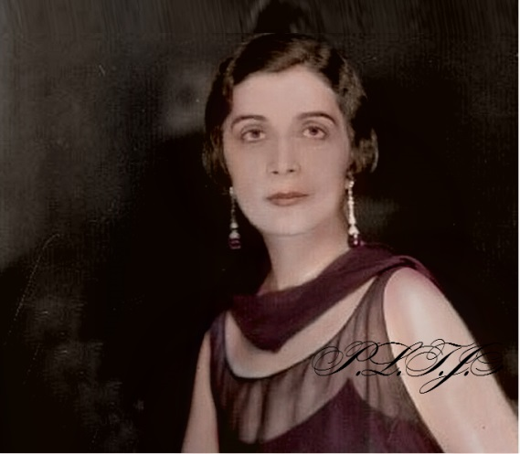
MARTHE BIBESCO

Marthe, Princess Bibesco (28 January 1886 – 28 November 1973), was a celebrated Romanian-French writer, socialite and political hostess.
Bibesco's papers are at the Harry Ransom Center at the University of Texas at Austin.
The third child of Ioan Lahovary and of Emma Lahovary, née princess Mavrocordat, Marthe spent her childhood on the Lahovary family's estates at Balotesti and in the fashionable French sea-resort Biarritz. On her first introduction into society, in 1900, she met Crown Prince Ferdinand, the Heir Apparent to the Romanian throne, but after a secret engagement of one year, Marthe married at 17 Prince George III Valentin Bibesco, scion of one of the country's prestigious aristocratic families. “I stepped onto the European stage through the grand door”, she wrote on her wedding day. Her father, who had been educated in France, held the post of minister of the Kingdom of Romania in Paris and, later, that of minister of foreign affairs of Romania.
Fluent in French at an early age (even before she could speak Romanian), Marthe spent the first years of her marriage under the tutelage of her mother-in-law, the princess Valentina, who saw to it that the extensive education in European history and literature Martha already had was reinforced. An old peasant woman, Baba Uta, saw to it that she was also well-versed in Romanian folk traditions and tales.
In 1905, she eagerly embarked on the trip, recording her observations in a journal. Along the way, she stopped at Yalta, where she encountered the exiled Russian writer Maxim Gorki. It was in 1908, at the suggestion of Maurice Barrès, that Marthe completed her impression of her Persian trip and published them. The French critics and writers were enthusiastic and amazingly complimentary. The travel memories she wrote about what she saw, Les Huit Paradises ("The Eight Paradises"), launched her on a lifelong career as a successful writer of both nonfiction and novels. She became the toast of Belle Epoque Paris, moving easily among the literary, aristocratic and political power elites. She was awarded the Prix de l'Academie Française and met Marcel Proust, who sent her a letter praising her book: “You are not only a splendid writer, Princess, but a sculptor of words, a musician, a purveyor of scents, a poet.”
Acclaimed as each new book appeared - Le Perroquet Vert (1923), Cathérine-Paris (1927), Au bal avec Marcel Proust (1928) - Marthe gravitated toward political power more than anything else.
In January 2001, a national poll of the most influential women in Romania's history placed princess Marthe Bibesco in the first position as the woman of the Millennium and of the 20th century.
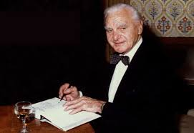

ION RAȚIU
Ion Rațiu (6 June 1917 – 17 January 2000) was the most outspoken and consistent voice of opposition to Nicolae Ceauşescu, who was a supporter of the communist regime. Journalist, broadcaster and author, Ion Rațiu was also a successful businessman in shipping and property, while simultaneously assisting in the rescue and support of many who fled Ceausescu’s dictatorship.
After 50 years in exile in London he returned to his homeland in 1990 to contest the presidency representing the Christian Democratic National Peasants' Party (PNȚ). During the televised confrontation between him and the other candidates (Radu Câmpeanu and Ion Iliescu), he was asked what he would do if he didn’t win the election campaign. His answer was the following: “All my life I’ve been fighting for democracy. I’ll fight to bring the essential element of democracy, which is not just a game of numbers based on who has more votes. This is not democracy. Democracy means understanding that the human is the centre of the society. Democracy means that you first listen to a person and then reject their point of view. The quintessence of democracy can be expressed just in a simple phrase: I’ll fight until my last drop of blood, so that you’ll have the right to disagree with me. If you can do this, than this means we have learnt what democracy is. If I am not elected, my target will still be to bring democracy in this country, not only in my party. I’ll dedicate my whole life to this!”
Although he was not elected as a president, he kept his promises. He even established an organisation, “The Raţiu Family Foundation”, which supports the “Ion Raţiu Democracy Award”. It aims to bring international recognition to the ideas and accomplishments of individuals around the world who are working on behalf of democracy.
All in all, Raţiu had a major contribution to spreading the democracy. Perhaps if it hadn’t been for him, Romania would have still had a communist regime…
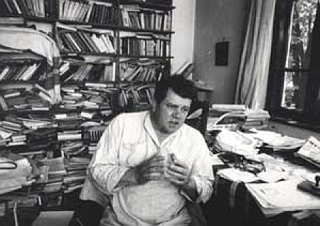
IOAN ALEXANDRU

Ioan Alexandru (born Ion Șandor, December 25, 1941 in Topa Mică, Cluj County, Romania - September 16, 2000 in Bonn, Germany) was a Romanian poet, essayist and politician. After the Romanian Revolution of 1989, Ioan Alexandru became a founding member and vice-president of the PNŢCD (Christian-Democratic National Peasants' Party of Romania). He was elected to the Chamber of Deputies during the 1992 elections, and again in 1996 to the Romanian Senate as a senator from Arad County.
On the night of December 21, 1989, the poet Ioan Alexandru held up a cross and an icon of Jesus Christ among soldiers, injured people and participants to the manifestation against Ceaușescu's regime in Bucharest, from the square "Piața Romană" to the "University Square".
His unique act that December night 1989, in the whole communist block, his courage, his resistance under the communist regime and his Christian testimony, all these things proved his courage during the atheist-communist regime. In recognition of his courage, the poet Ioan Alexandru has received from the U.S. Congress the American flag "Old Glory", which was on the Congress' building on August 31, 1993, in honour of Romania. Ioan Alexandru is the co-founder of the Prayer Group in the Romanian Parliament, and the founder of the Christian association "Pro-Vita" in Romania.

